Downloaded the RDP File from virtual machine – Connect section and connected the VM using ID and Password. Successfully connected.
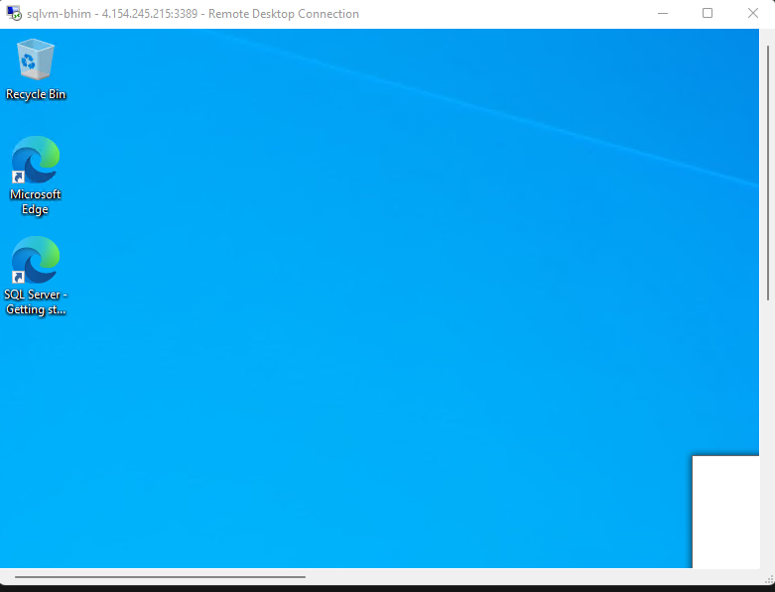

Go to Server manager – Local Server and disable IE Enhanced security Configuration. Otherwise it will ask for permission in browser again & again.
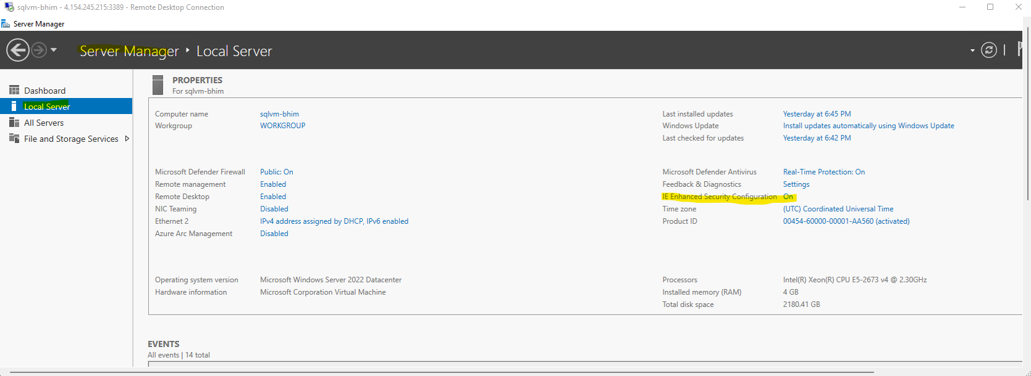

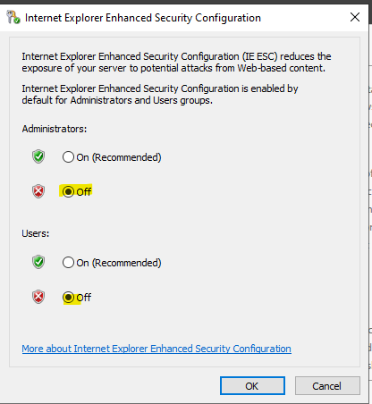

Go to edge browser and download the on prem gateway from Microsoft website.
URL - Install an on-premises data gateway | Microsoft Learn
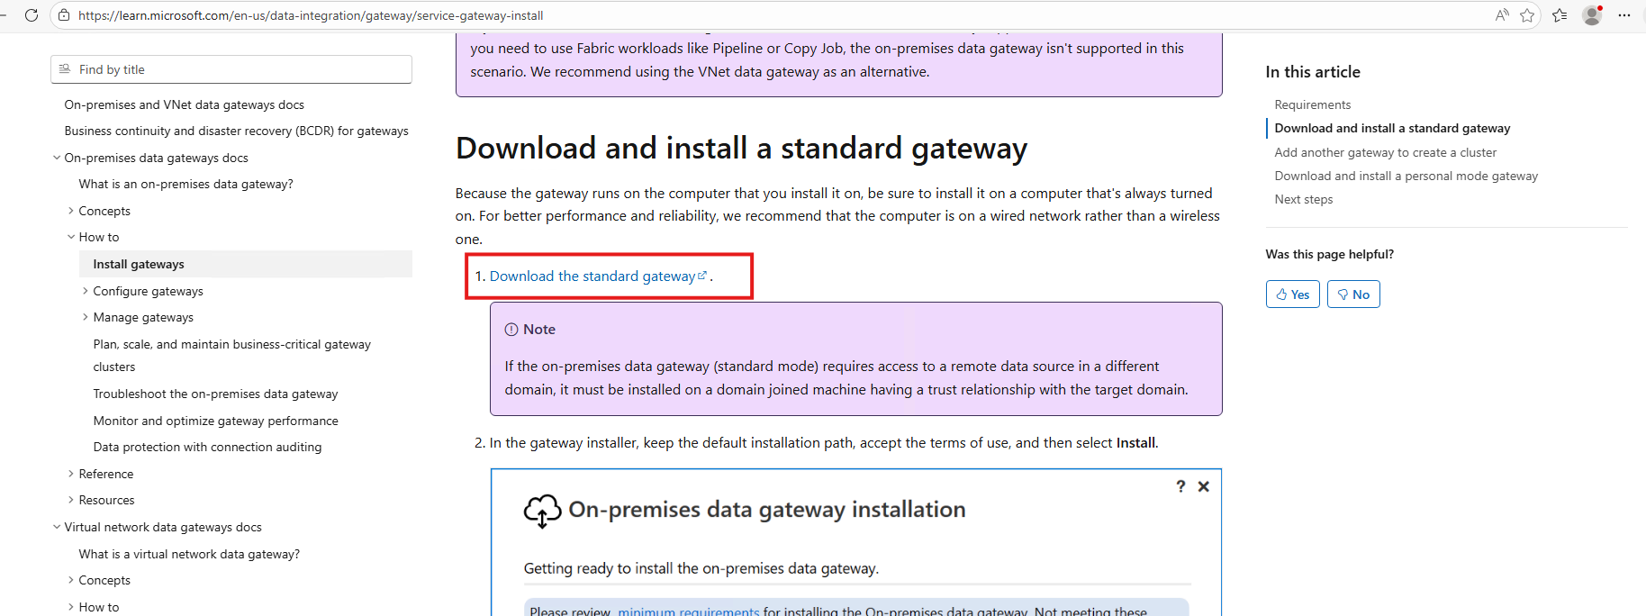
Install the exe file
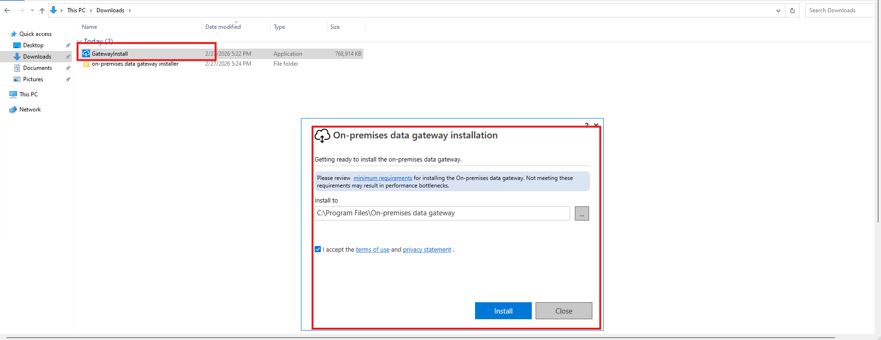

Paste the same email Id which is connected to fabric.
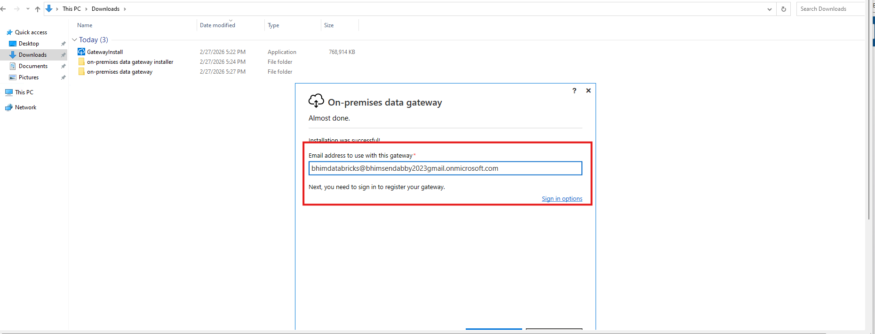

Register for –
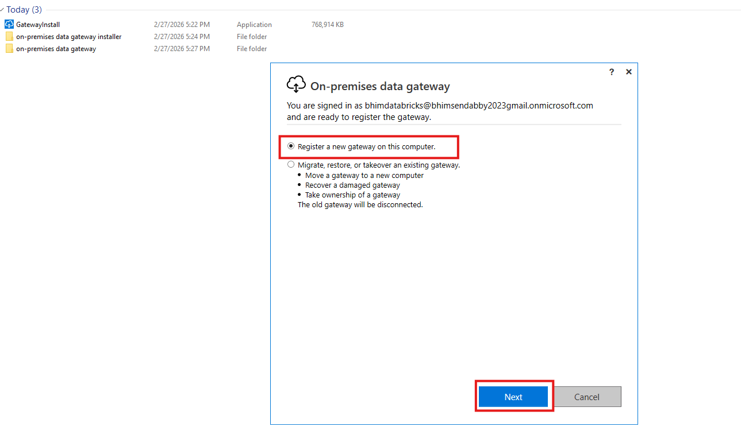
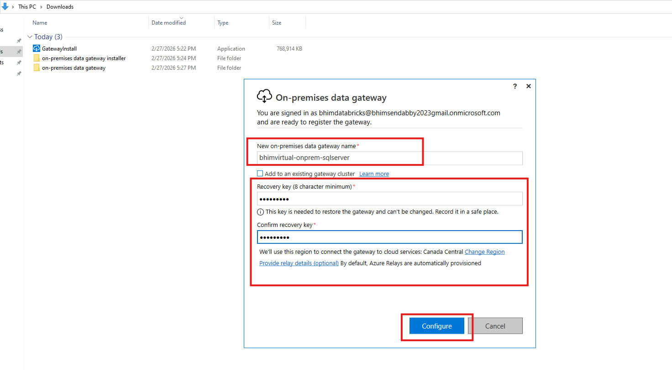
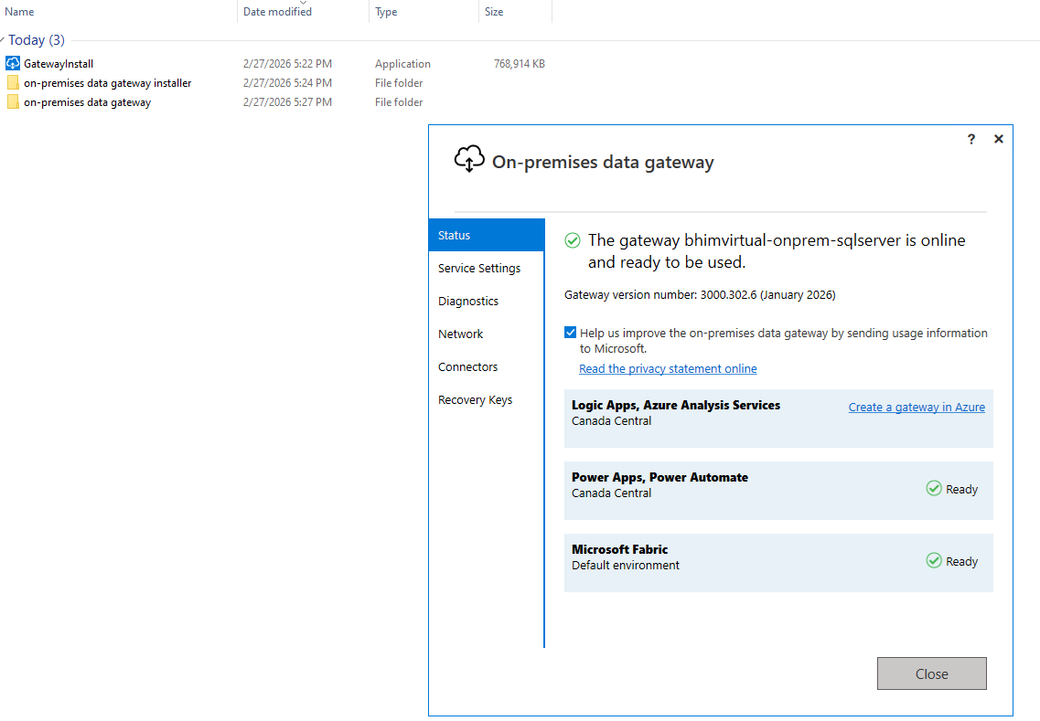

Open SSMS in your VM and select SQL Server authentication give the id and password same as your VM login credentials.
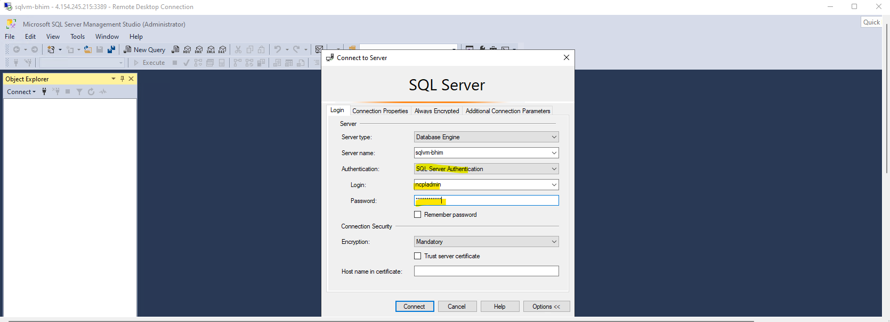
Create database.
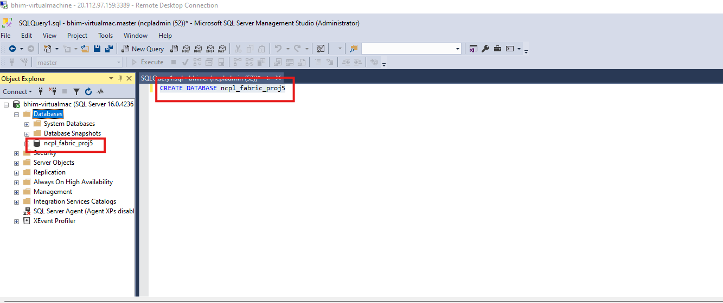
Select your database, create table and insert the data into that table.
Created 5 tables
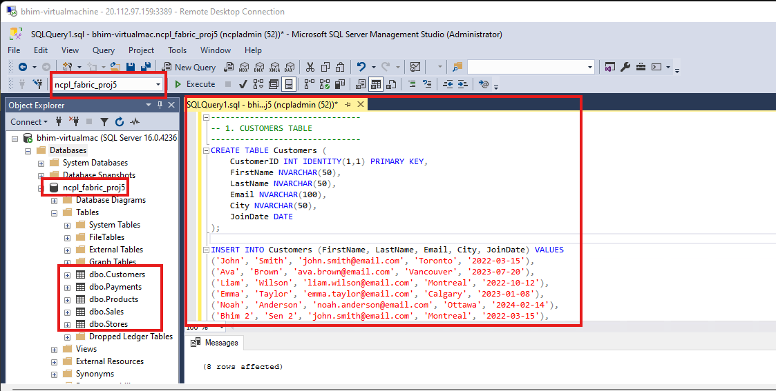
-------------------------------
-- 1. CUSTOMERS TABLE
-------------------------------
CREATE TABLE Customers (
CustomerID INT IDENTITY(1,1) PRIMARY KEY,
FirstName NVARCHAR(50),
LastName NVARCHAR(50),
Email NVARCHAR(100),
City NVARCHAR(50),
JoinDate DATE
);

INSERT INTO Customers (FirstName, LastName, Email, City, JoinDate) VALUES
('John', 'Smith', 'john.smith@email.com', 'Toronto', '2022-03-15'),
('Ava', 'Brown', 'ava.brown@email.com', 'Vancouver', '2023-07-20'),
('Liam', 'Wilson', 'liam.wilson@email.com', 'Montreal', '2022-10-12'),
('Emma', 'Taylor', 'emma.taylor@email.com', 'Calgary', '2023-01-08'),
('Noah', 'Anderson', 'noah.anderson@email.com', 'Ottawa', '2024-02-14'),
('Bhim 2', 'Sen 2', 'john.smith@email.com', 'Montreal', '2022-03-15'),
('Bhim', 'Sen', 'john.smith@email.com', 'Toronto', '2022-03-15');

-------------------------------
-- 2. PRODUCTS TABLE
-------------------------------
CREATE TABLE Products (
ProductID INT IDENTITY(1,1) PRIMARY KEY,
ProductName NVARCHAR(100),
Category NVARCHAR(50),
UnitPrice DECIMAL(10,2),
StockQuantity INT
);

INSERT INTO Products (ProductName, Category, UnitPrice, StockQuantity) VALUES
('Laptop', 'Electronics', 999.99, 50),
('Headphones', 'Electronics', 79.99, 200),
('Coffee Maker', 'Home Appliances', 129.99, 80),
('Office Chair', 'Furniture', 199.99, 40),
('Water Bottle', 'Accessories', 19.99, 300);

-------------------------------
-- 3. STORES TABLE
-------------------------------
CREATE TABLE Stores (
StoreID INT IDENTITY(1,1) PRIMARY KEY,
StoreName NVARCHAR(100),
City NVARCHAR(50),
ManagerName NVARCHAR(100)
);

INSERT INTO Stores (StoreName, City, ManagerName) VALUES
('Downtown Toronto', 'Toronto', 'Sarah Lee'),
('Metrotown', 'Vancouver', 'David Kim'),
('Eaton Centre', 'Toronto', 'James Wong'),
('Chinook Mall', 'Calgary', 'Linda Green'),
('Rideau Centre', 'Ottawa', 'Robert White');

-------------------------------
-- 4. SALES TABLE
-------------------------------
CREATE TABLE Sales (
SaleID INT IDENTITY(1,1) PRIMARY KEY,
CustomerID INT FOREIGN KEY REFERENCES Customers(CustomerID),
StoreID INT FOREIGN KEY REFERENCES Stores(StoreID),
ProductID INT FOREIGN KEY REFERENCES Products(ProductID),
SaleDate DATE,
Quantity INT,
TotalAmount DECIMAL(10,2)
);

INSERT INTO Sales (CustomerID, StoreID, ProductID, SaleDate, Quantity, TotalAmount) VALUES
(1, 1, 1, '2024-09-15', 1, 999.99),
(2, 2, 2, '2024-10-05', 2, 159.98),
(3, 3, 3, '2024-11-12', 1, 129.99),
(4, 4, 4, '2024-12-01', 1, 199.99),
(5, 5, 5, '2024-12-25', 3, 59.97),
(1, 1, 2, '2025-01-15', 1, 79.99),
(2, 2, 5, '2025-02-10', 2, 39.98),
(3, 3, 1, '2025-03-05', 1, 999.99);

-------------------------------
-- 5. PAYMENTS TABLE
-------------------------------
CREATE TABLE Payments (
PaymentID INT IDENTITY(1,1) PRIMARY KEY,
SaleID INT FOREIGN KEY REFERENCES Sales(SaleID),
PaymentMethod NVARCHAR(50),
PaymentDate DATE,
Amount DECIMAL(10,2)
);

INSERT INTO Payments (SaleID, PaymentMethod, PaymentDate, Amount) VALUES
(1, 'Credit Card', '2024-09-15', 999.99),
(2, 'Debit Card', '2024-10-05', 159.98),
(3, 'Cash', '2024-11-12', 129.99),
(4, 'Credit Card', '2024-12-01', 199.99),
(5, 'PayPal', '2024-12-25', 59.97),
(6, 'Credit Card', '2025-01-15', 79.99),
(7, 'Debit Card', '2025-02-10', 39.98),
(8, 'Credit Card', '2025-03-05', 999.99);

Go to fabric check for gateway
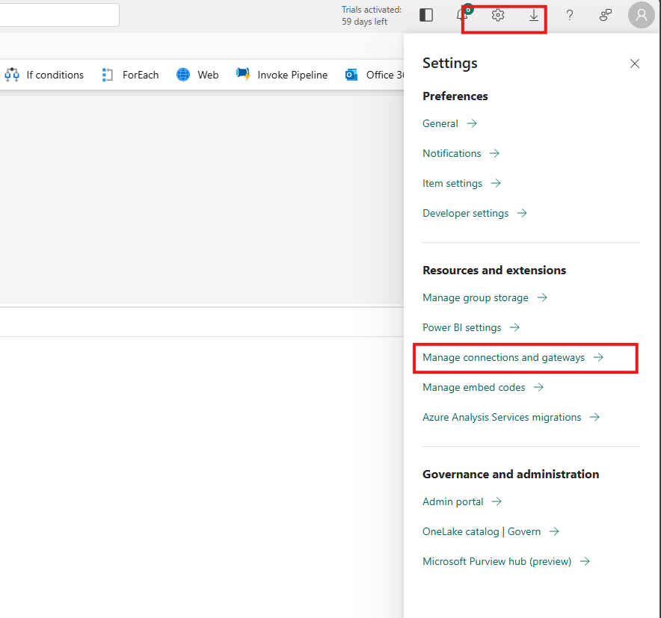
Check the gateway name and status.
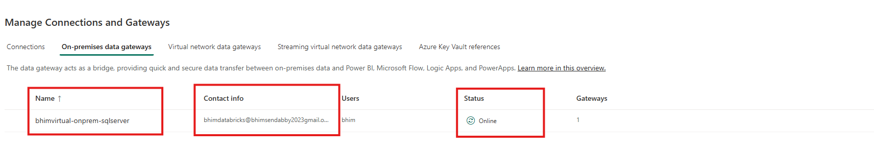

Go to fabric and create a pipe line copy activity
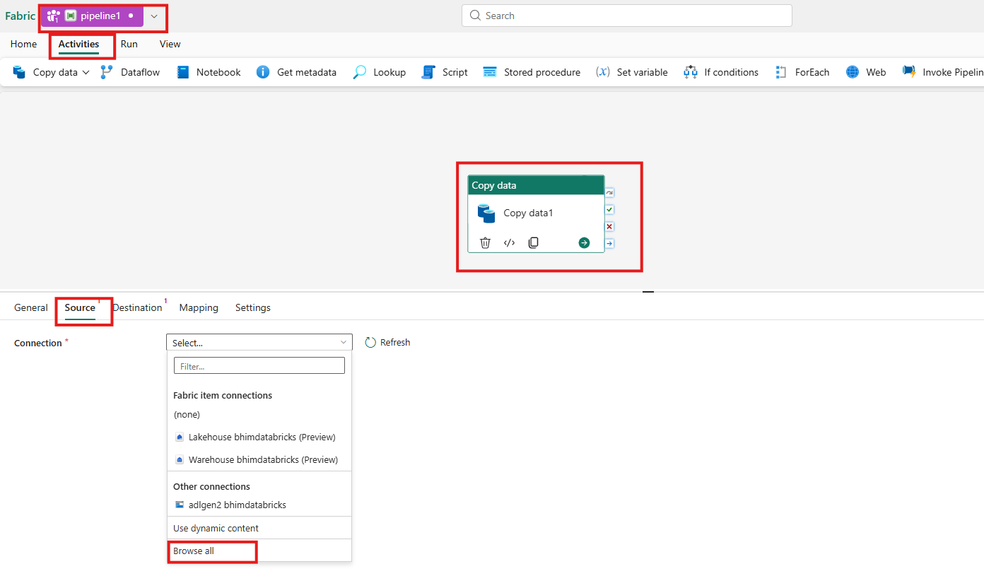
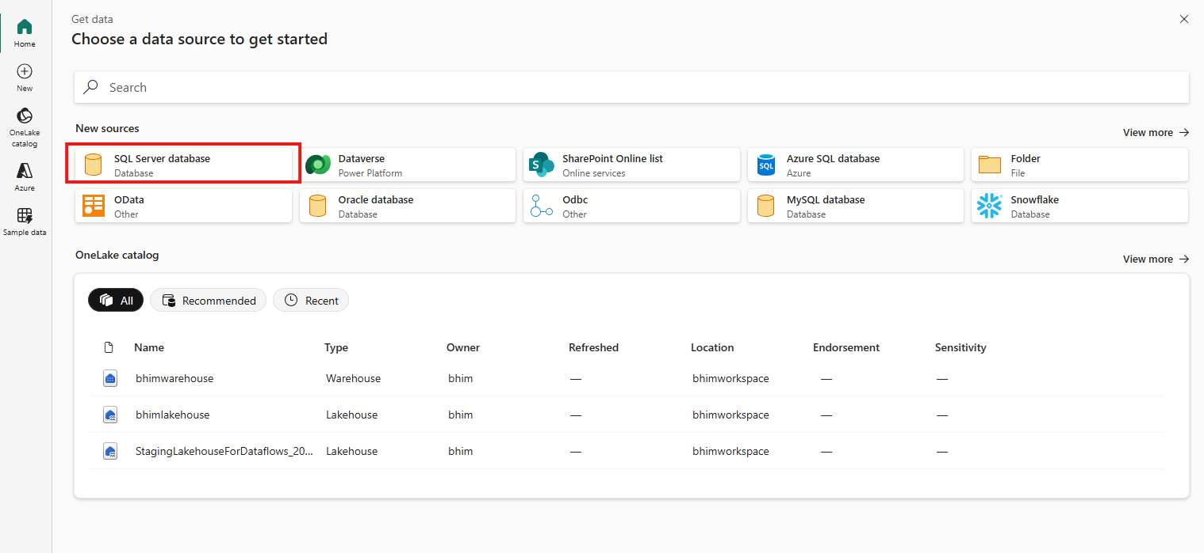
Go to virtual machine and ssms get the server name
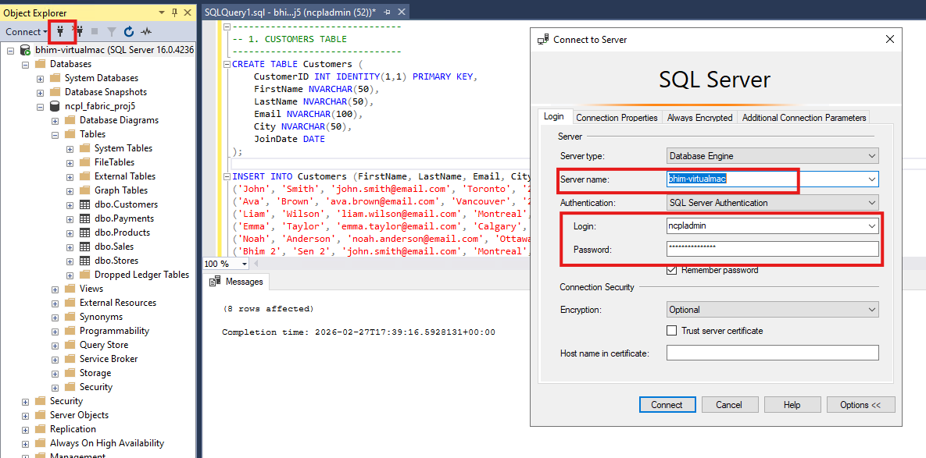

Select gatway, database username and password

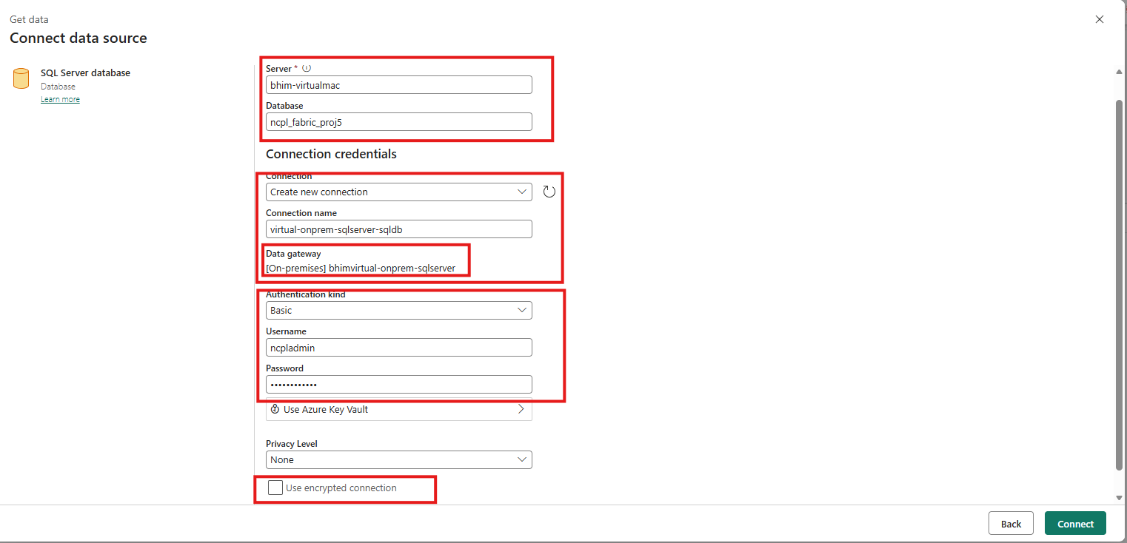

Create Parameter schemaName, fileName and Tablename. Then select the dynamically the schemaName and Tablename.

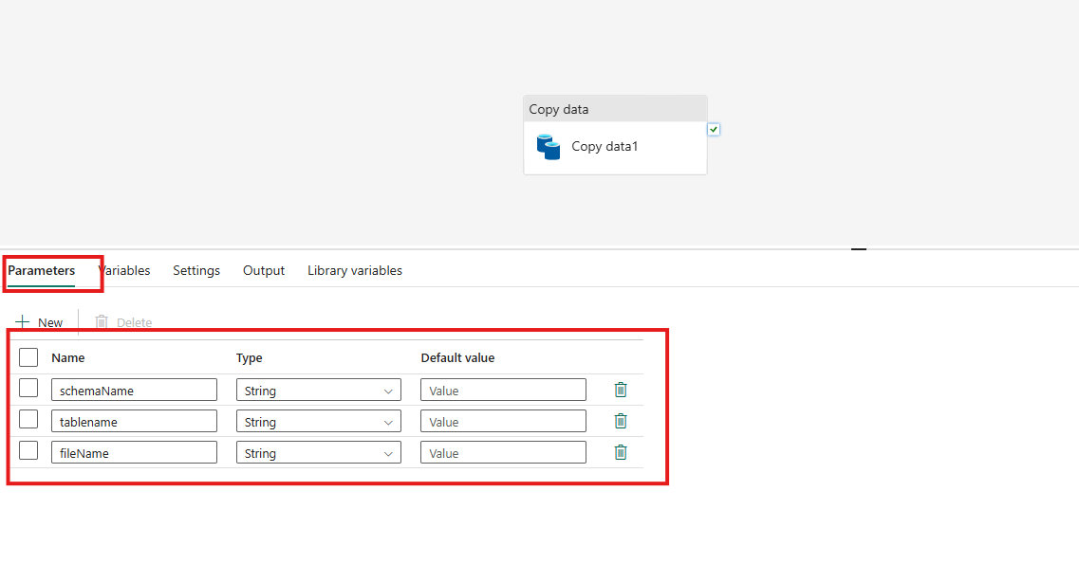
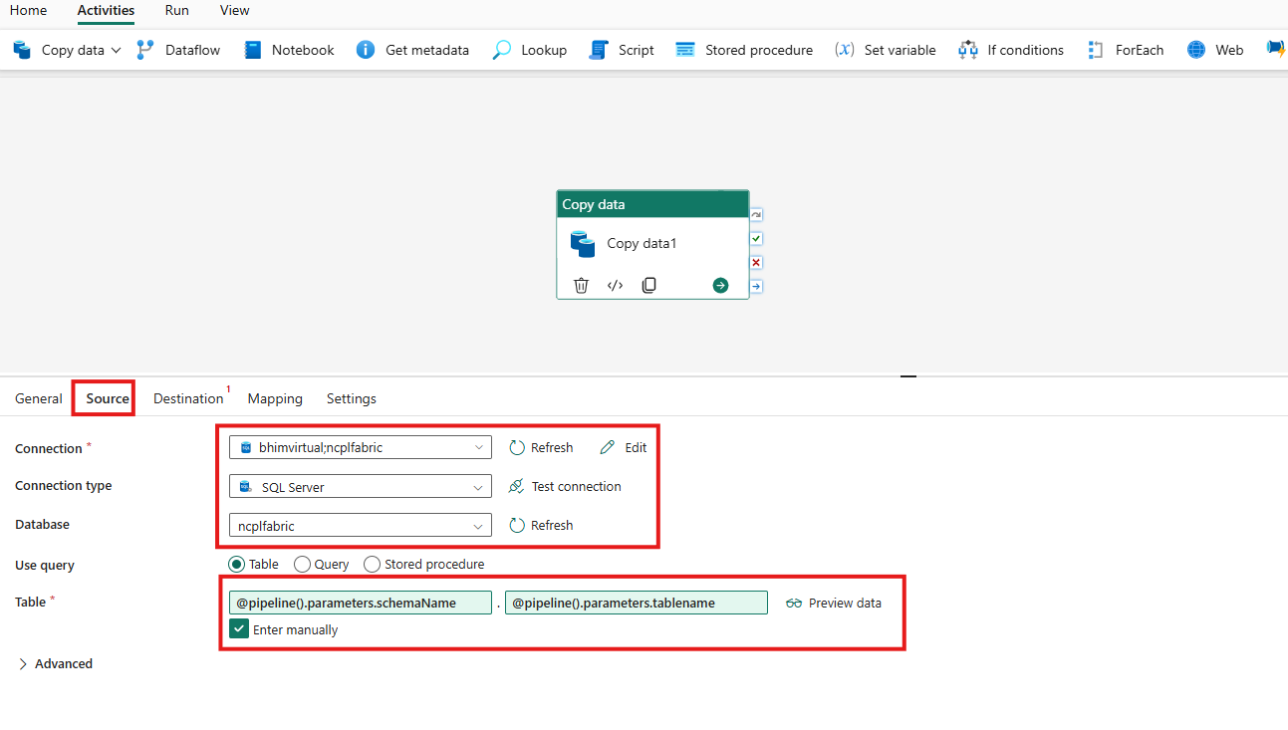
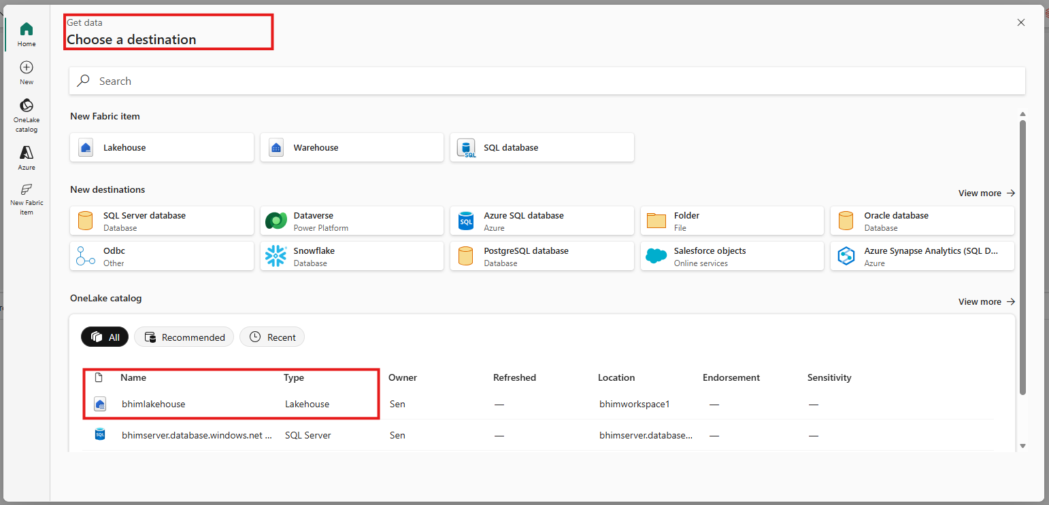

Create a folder in the lakehouse file section – bronzelayer.
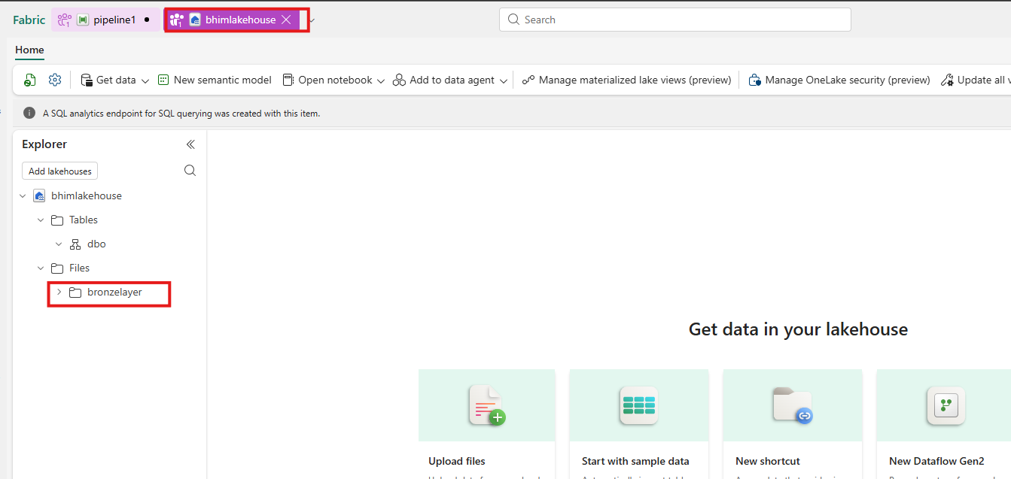
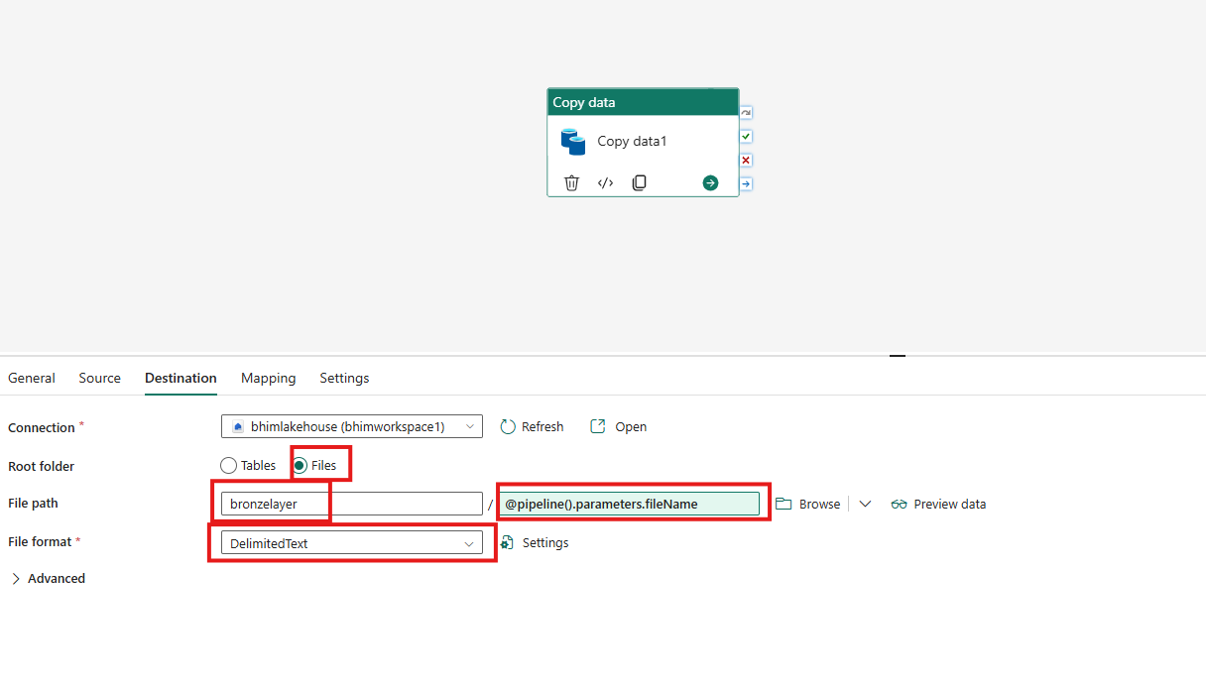
Run the pipeline by passing the parameters
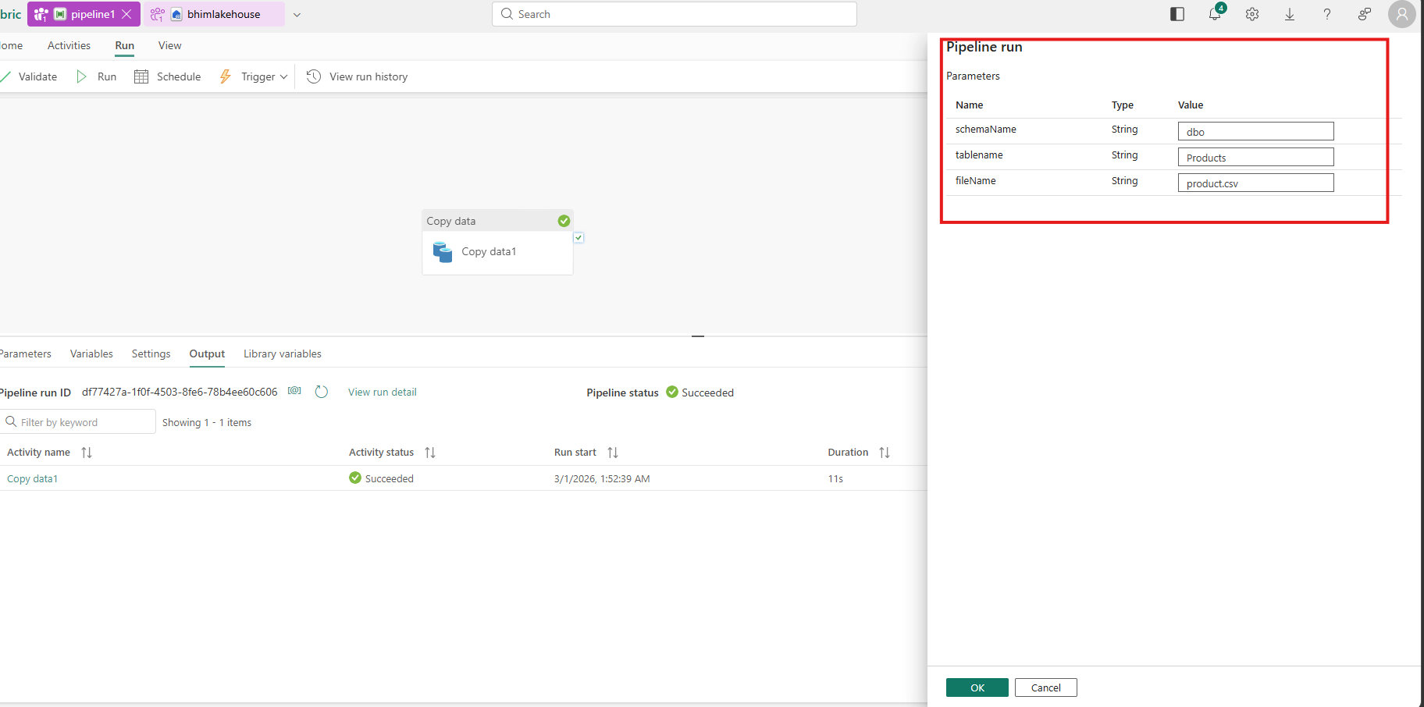

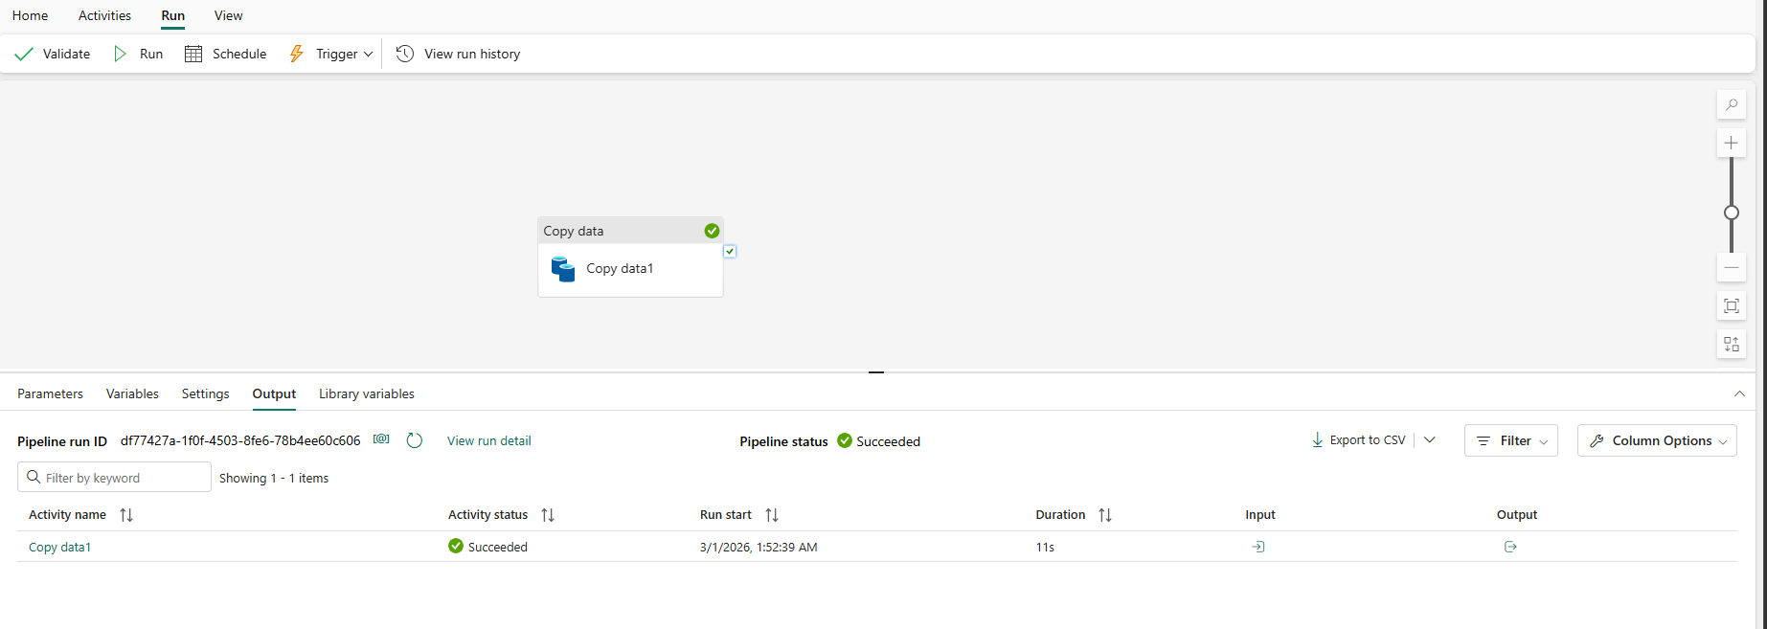

Lakehouse
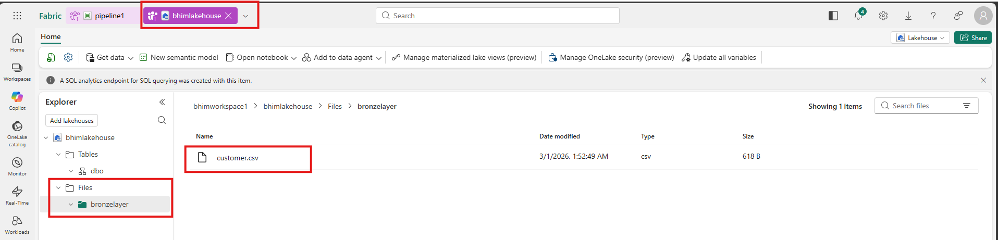

Successfully copied the data from on-prem to fabric lakehouse.

